Order Of Service

Singing: Psalm 8—CW page 67

Reading: Psalm 127

Opening Hymn: TLH 17

Reading: Romans 11:1-10

Request Hymn: CW Supplement 707

Reading: Matthew 21:23-27

Sermon Hymn: TLH 404

Sermon Text: Luke 3:10-14

What Shall We Do?

Prayer

The Apostles’ Creed, TLH page 12

Holy Communion

The Lord's Prayer

The Blessing

Closing Hymn: TLH 400

Bible Study: Lambs: Emperor Penguin
Sheep: Proverbs 27:11-15
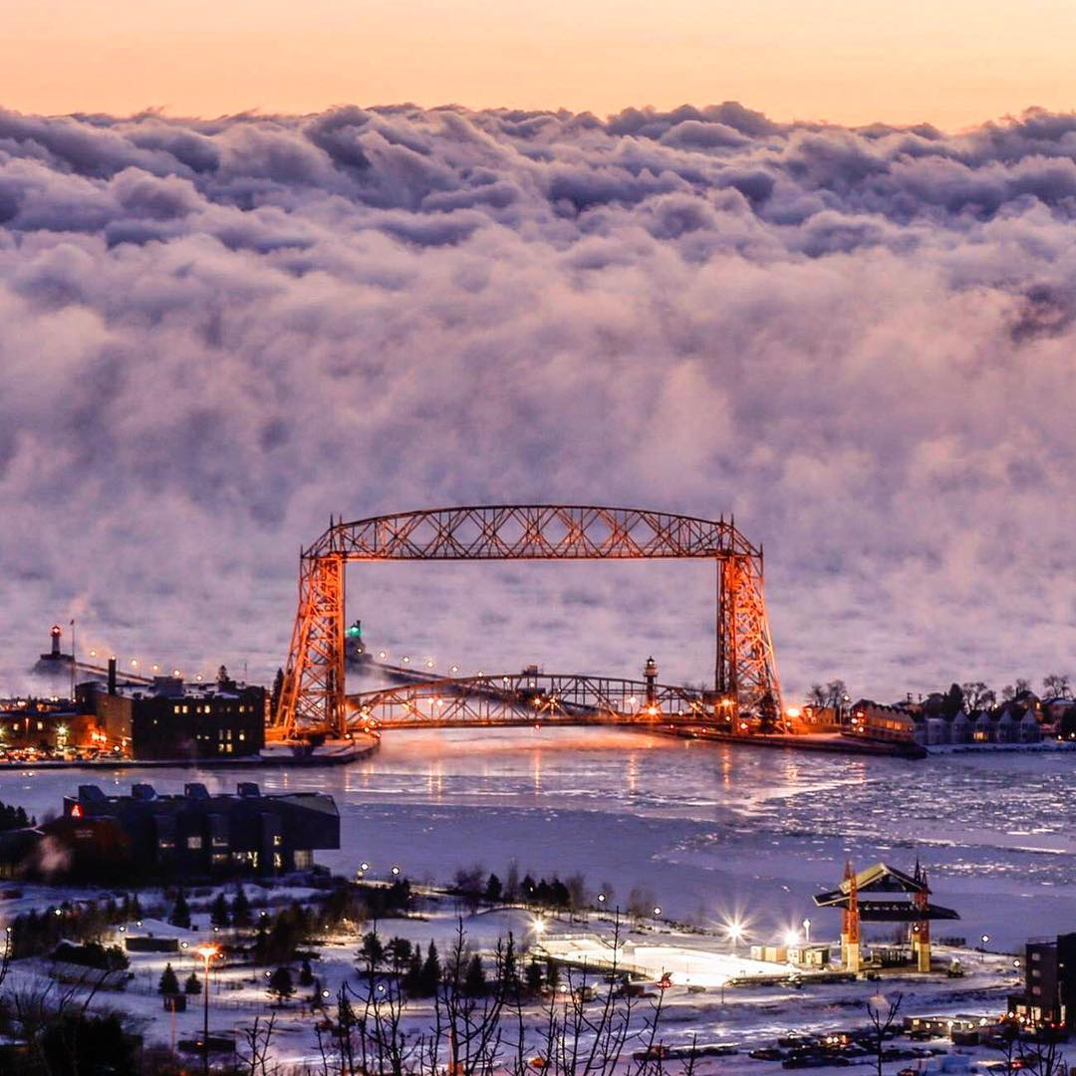

Water
Of
Life
27 December 2020

W A T E R O F L I F E

Independent Christian Church—Conservative Lutheran Doctrine

Worship Service: 9:30 a.m. Bible Study: 10:45 a.m.

Larry Cooper, Pastor E-Mail address:
111 N. Ridge Road lcooper@wateroflife.cc
Coon Valley, WI 54623 Web Site:
www.wateroflife.cc

* * * * * * * * * * * * * * * * * * * * * * * * * * *

Sermon Text: Luke 3:10-14

What Shall We Do?

* * * * * * * * * * * * * * * * * * * * * * * * * * *

Luke 3:10 And the people asked him, saying, What shall we do then?
:11 He answereth and saith unto them, He that hath two coats, let him impart to him that hath none; and he that hath meat, let him do likewise.
:12 Then came also publicans to be baptized, and said unto him, Master, what shall we do?
:13 And he said unto them, Exact no more than that which is appointed you.
:14 And the soldiers likewise demanded of him, saying, And what shall we do? And he said unto them, Do violence to no man, neither accuse any falsely; and be content with your wages.



